**LAPORAN JOBSHEET 6**

“Navigation 2”

**PEMPROGRAMAN SISTEM BERGERAK**



**Mutiara Hermalina**

**20076012**

**Dosen Pengampu:**

**Geovanne Farell S.Pd,M.Pd.T**

**PENDIDIKAN TEKNIK INFORMATIKA**

**TEKNIK ELEKTRONIKA**

**UNIVERSITAS NEGERI PADANG**

**2022**

LANGKAH KERJA

1. Buka CMD – Lalu akses file project yang telah dibuat sebelumnya,
2. Tambahkan yarn add react-navigation react-navigation-tabs
3. Selanjutnya kita akan menggunakan FontAwesome untuk ikonnya. Untuk itu kita perlu menambahkannya pada project: yarn add react-native-svg @fortawesome/fontawesome-svg-core @fortawesome/freesolid-svg-icons @fortawesome/react-native-fontawesome
4. Tambahkan yarn add react-native-reanimated

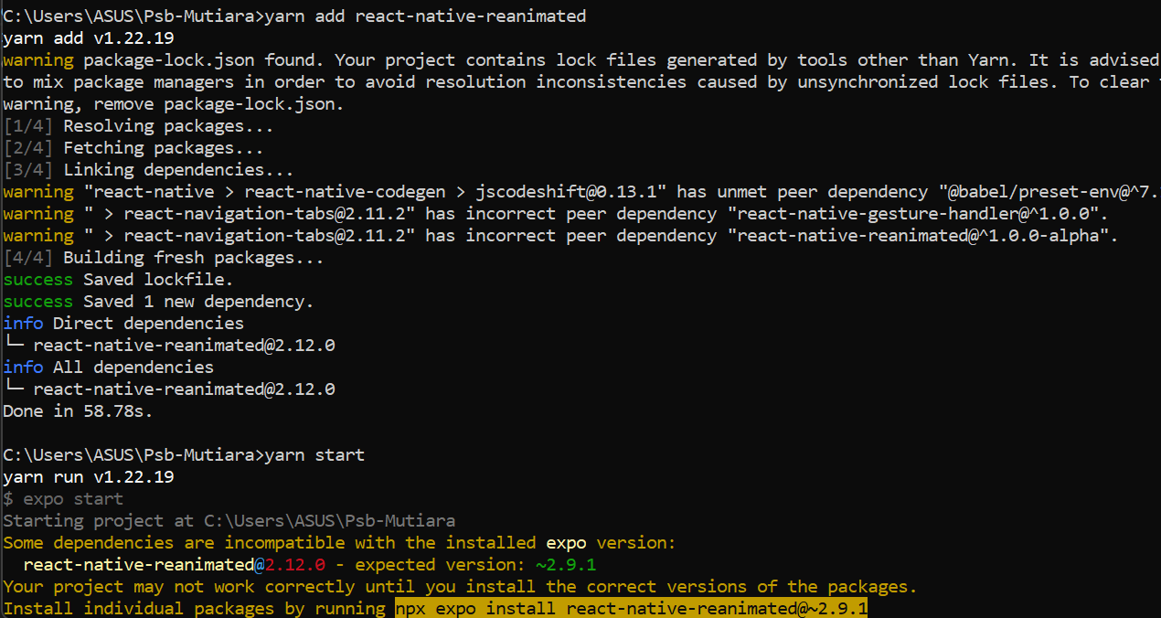

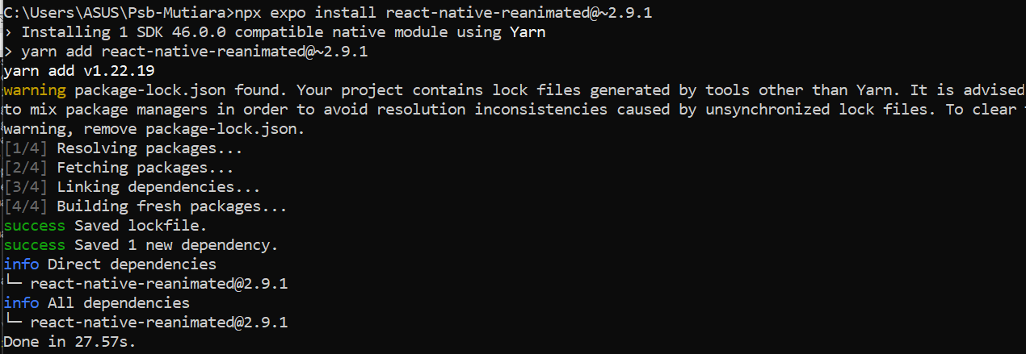

Source code DetailsScreen.js

import { View, Text, TouchableOpacity } from 'react-native'

import React from 'react'

const DetailScreen = ({ route }) => {

    return (

        <View>

            <Text>Hello Ini Adalah DetailScreen</Text>

            <Text>

                {route.params.itemId}

            </Text>

            <Text>

                {route.params.otherParam}

            </Text>

            <TouchableOpacity onPress={() => route.params.otherFunction}>

                <Text>Hello ini Pemrograman Sistem Bergerak</Text>

            </TouchableOpacity>

        </View>

    )

}

export default DetailScreen

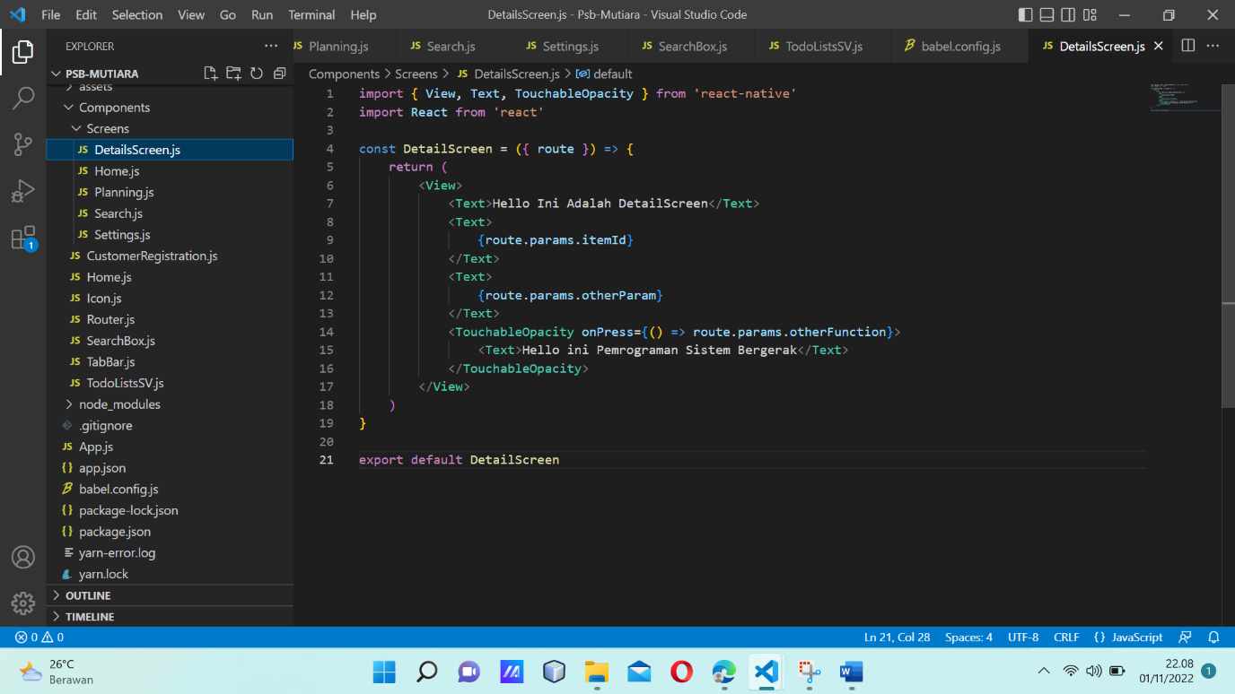

Source code Home.js

import { View, StyleSheet, Text } from 'react-native'

import React from 'react'

export default function Home() {

    return(

        <View style={styles.container}>

            <Text>HOME</Text>

        </View>

    )

}

const styles = StyleSheet.create({

    container:{

        flex:1,

        backgroundColor: 'cyan',

        alignItems: "center",

        justifyContent: 'center',

    }

})

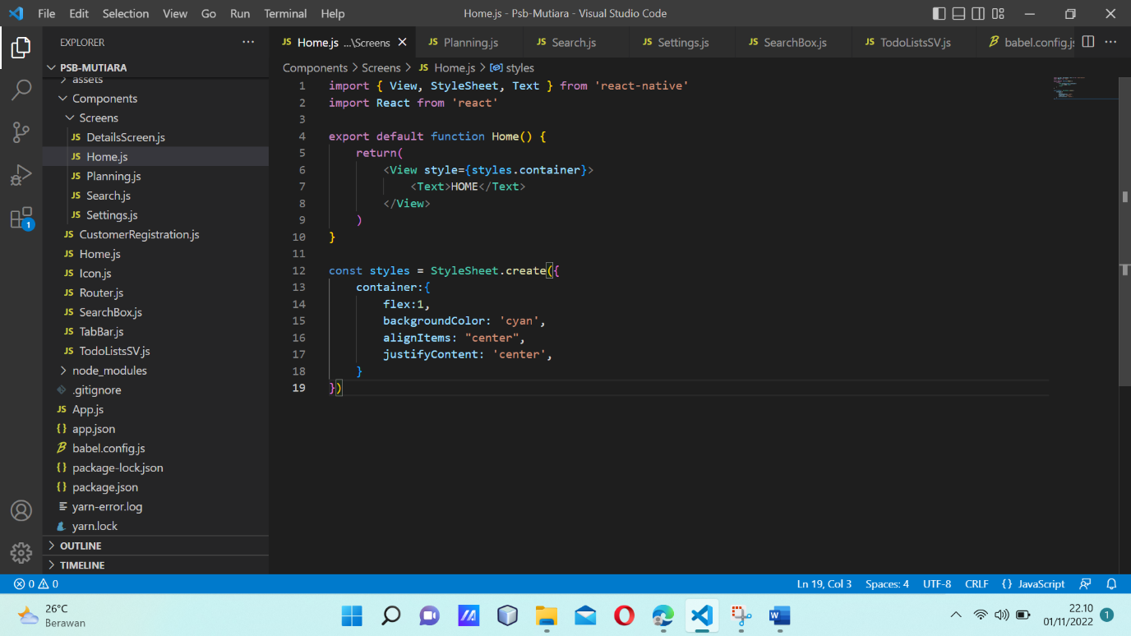

Source Code Planning.js

import { View, StyleSheet, Text } from 'react-native'

import React from 'react'

export default function Planning() {

    return(

        <View style={styles.container}>

            <Text>PLANNING</Text>

        </View>

    )

}

const styles = StyleSheet.create({

    container:{

        flex:1,

        backgroundColor: 'red',

        alignItems: "center",

        justifyContent: 'center',

    }

})

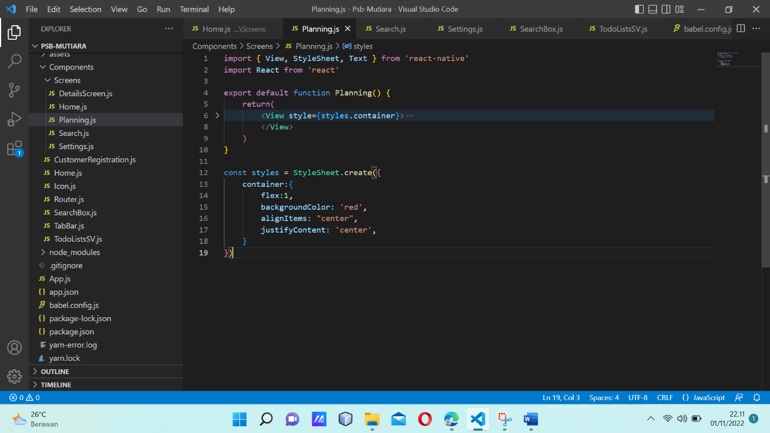

Source code Search.js

import { View, StyleSheet, Text } from 'react-native'

import React from 'react'

export default function Search() {

    return(

        <View style={styles.container}>

            <Text style={styles.tx1}>SEARCH</Text>

        </View>

    )

}

const styles = StyleSheet.create({

    container:{

        flex:1,

        backgroundColor: 'pink',

        alignItems: "center",

        justifyContent: 'center',

    },

    tx1 :{

        fontWeight: 'bold',

        fontSize: 20,

    },

})

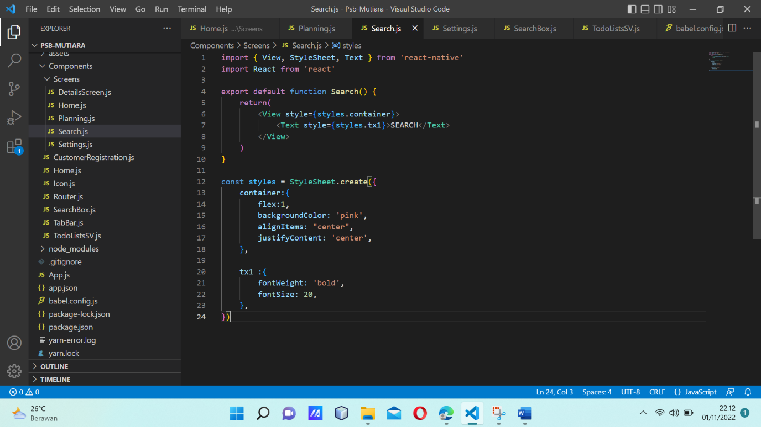

Source code Settings.js

import { View, StyleSheet, Text } from 'react-native'

import React from 'react'

export default function settings() {

    return(

        <View style={styles.container}>

            <Text>SETTINGS</Text>

        </View>

    )

}

const styles = StyleSheet.create({

    container:{

        flex:1,

        backgroundColor: 'green',

        alignItems: "center",

        justifyContent: 'center',

    }

})

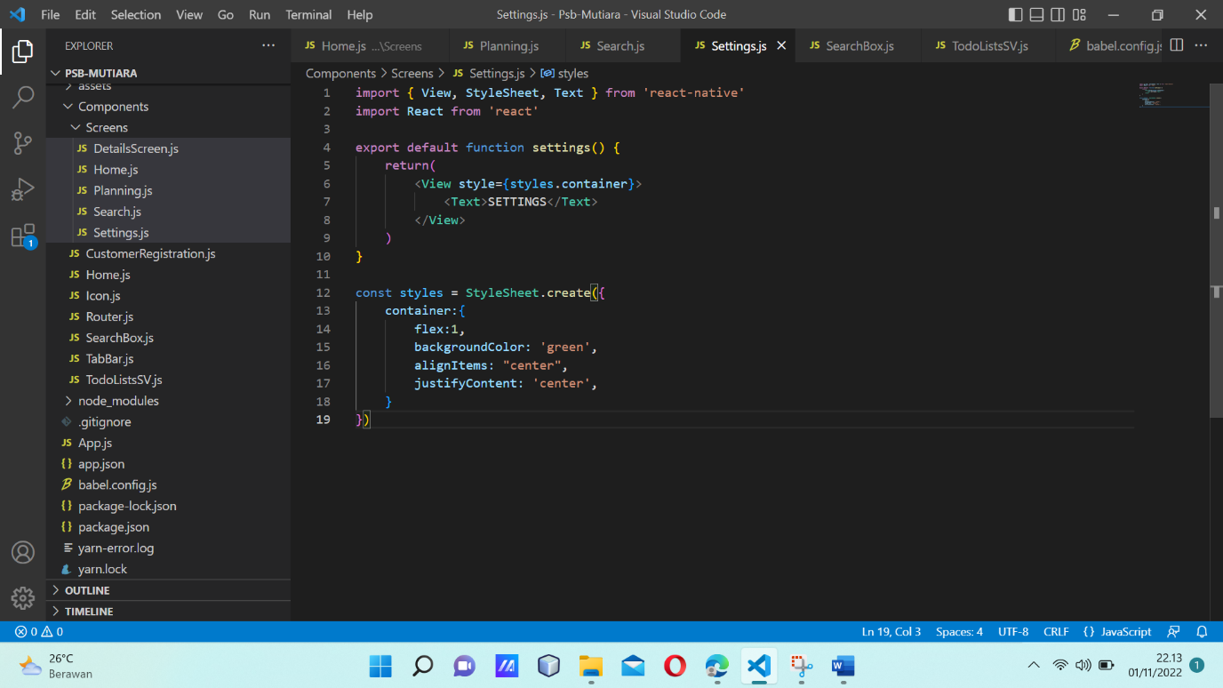

Source code CustomerRegistration.js

import {useState} from  'react'

import {View, Text, Button} from 'react-native'

const CustomerRegistration = () => {

    const[count, setCount] = useState(0)

    return (

        <View>

            <Text> PSB From Customer Registration </Text>

            <Text> Your Clicked : {count}</Text>

            <Button title="+" onPress={() =>setCount(count+1)}/>

            <Button title="-" onPress={() =>setCount(count-1)}/>

        </View>

    )

}

export default CustomerRegistration

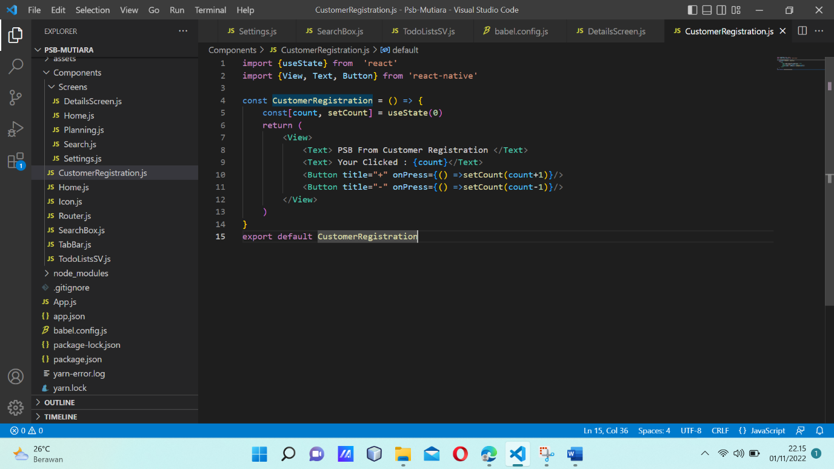

Source code HOME.JS

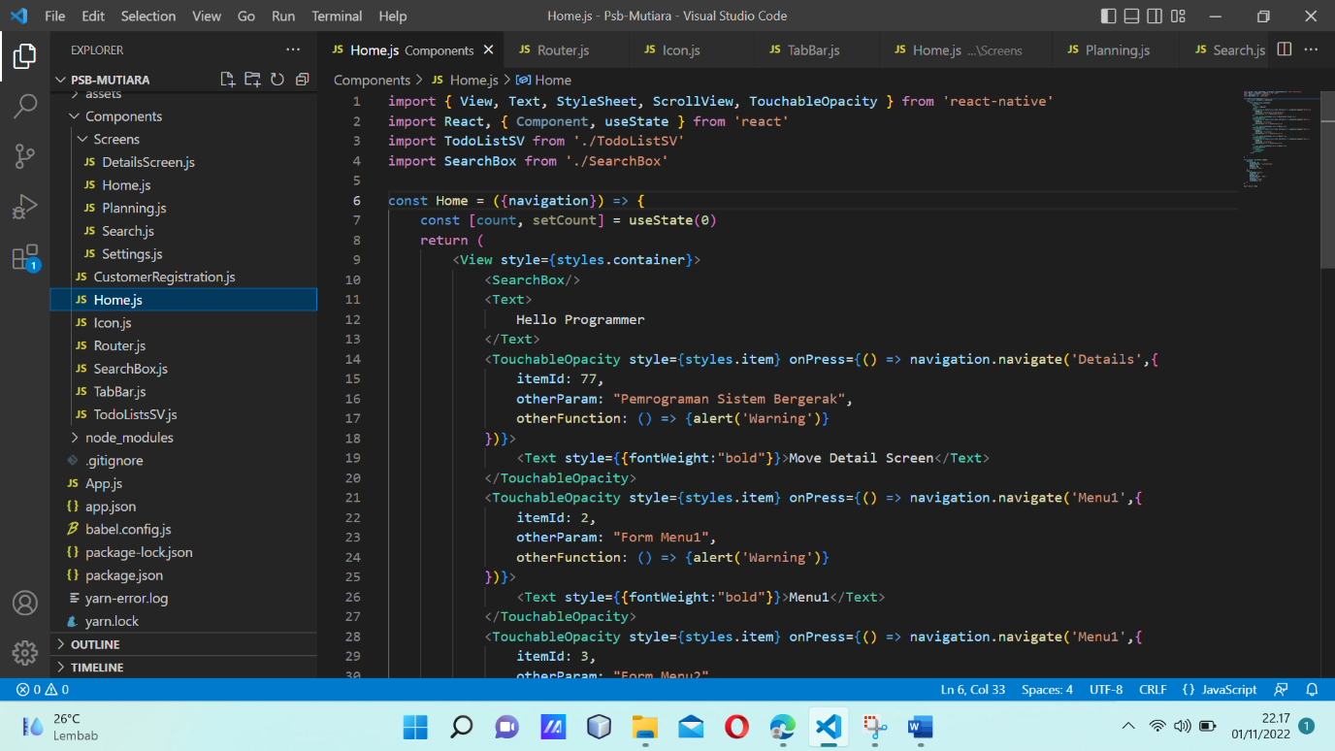

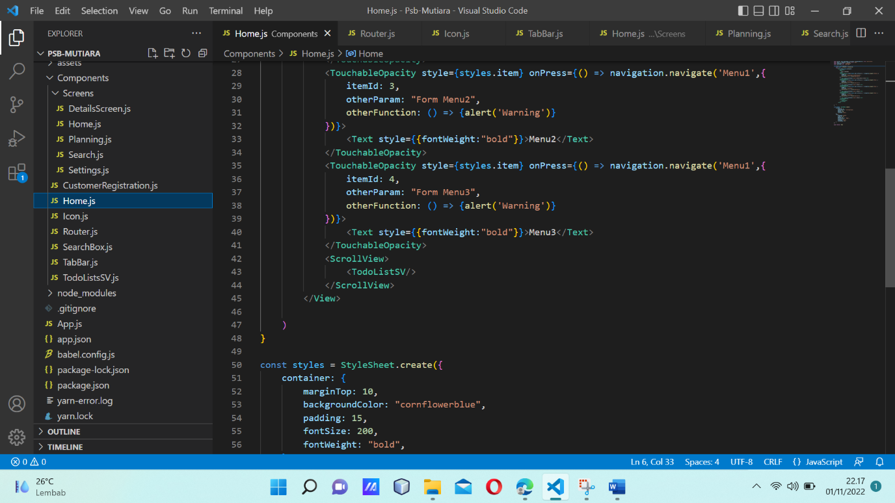

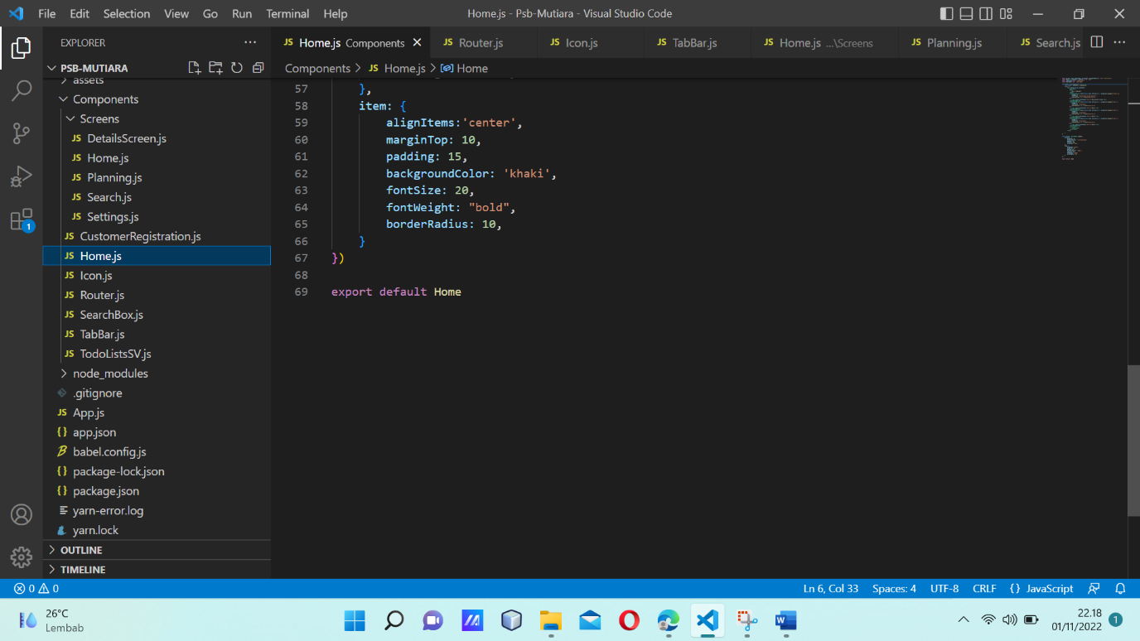

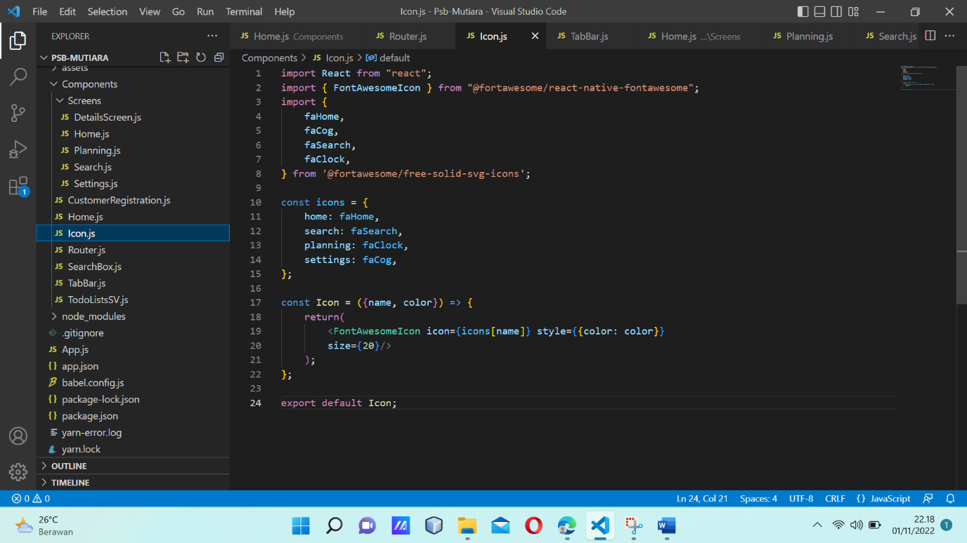

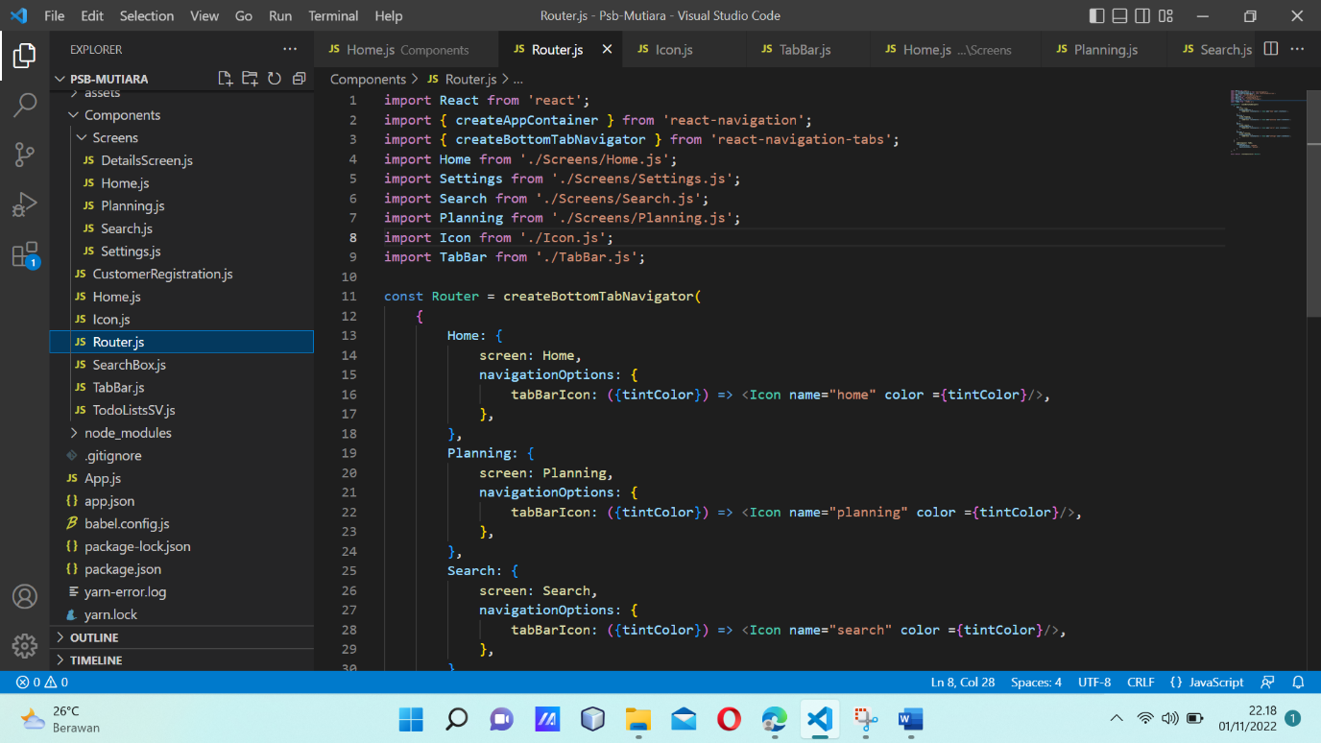

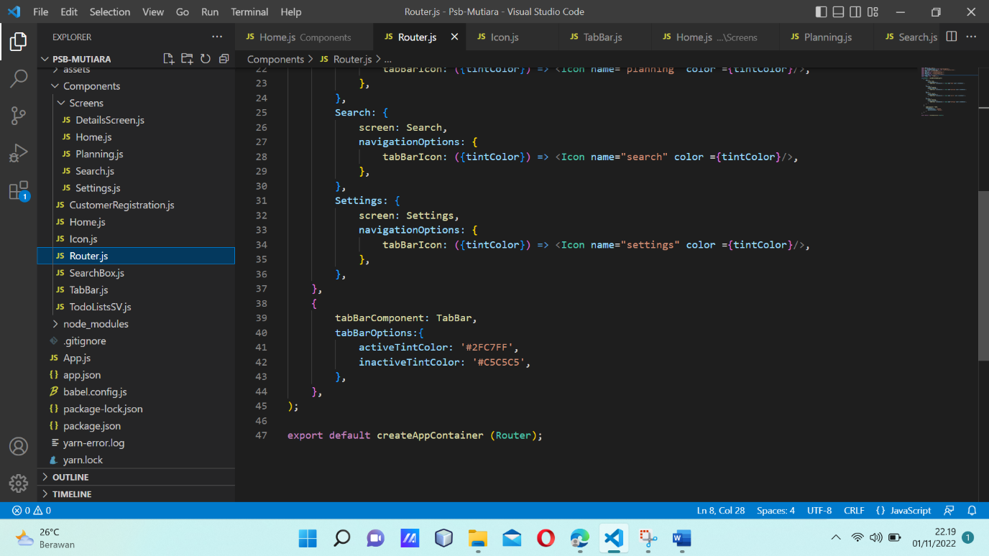

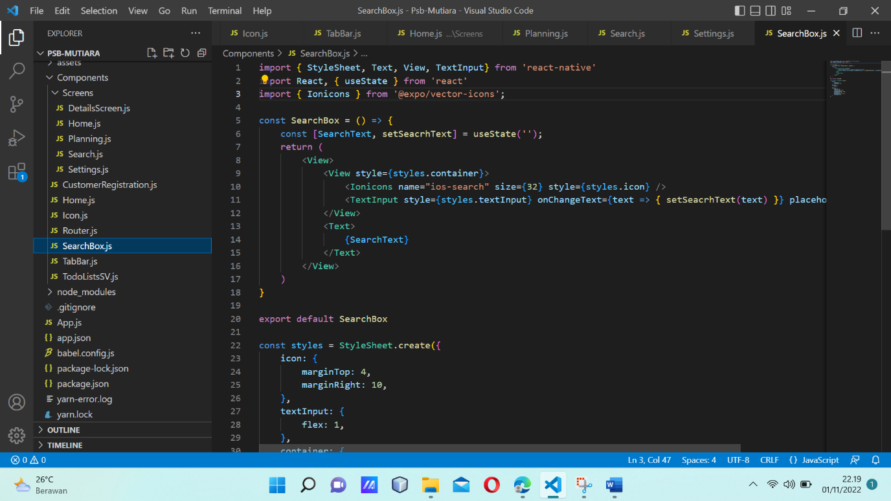

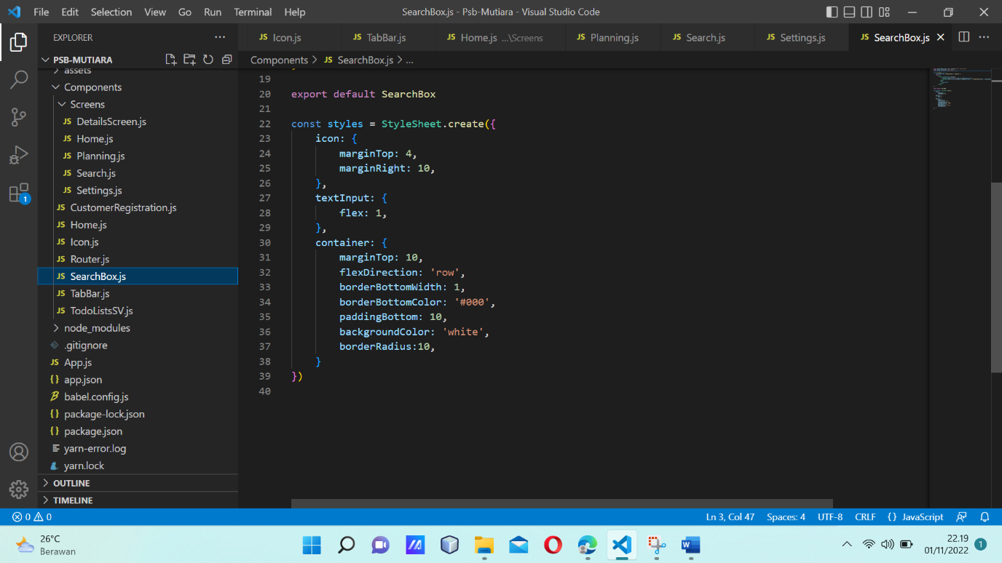

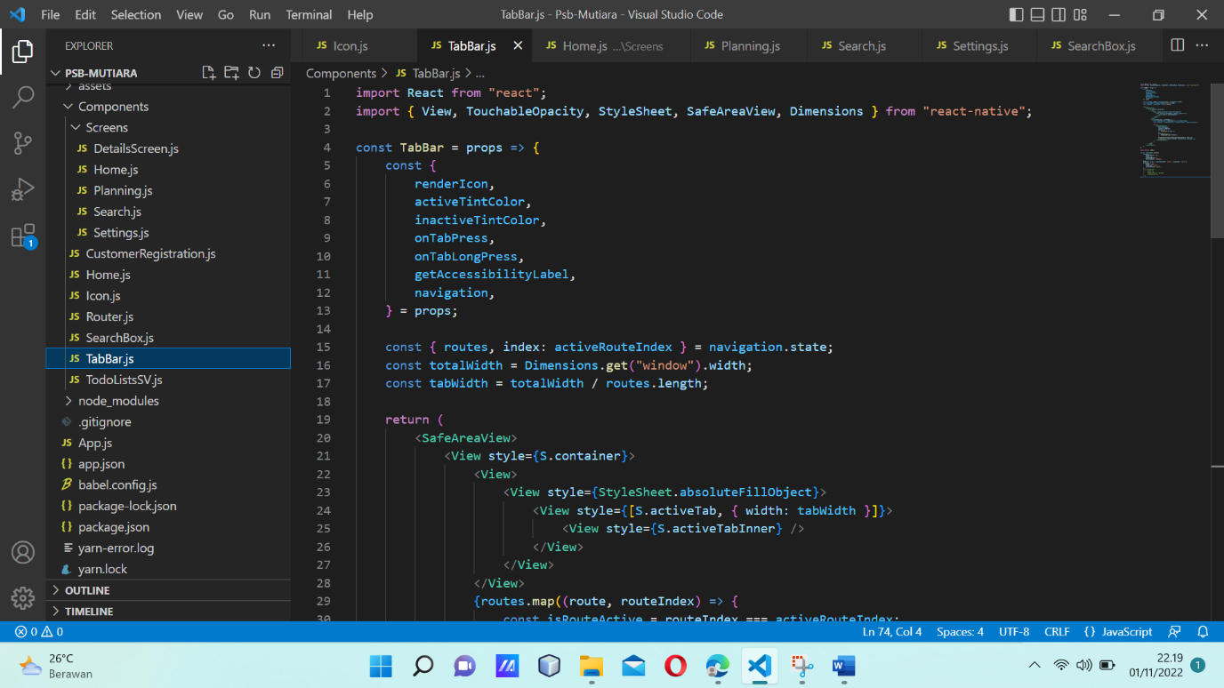

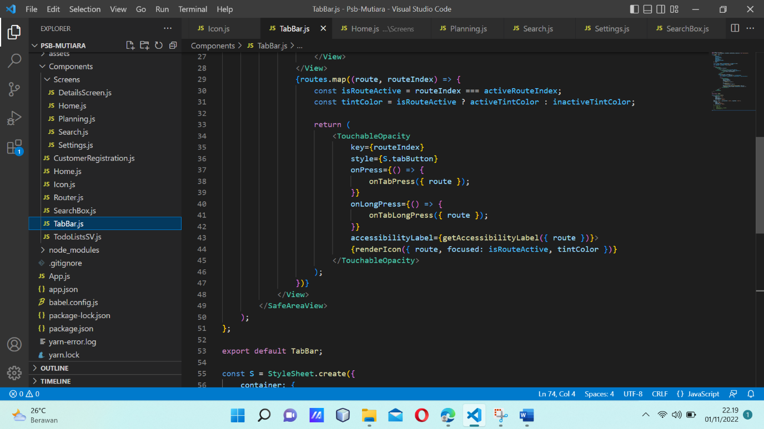

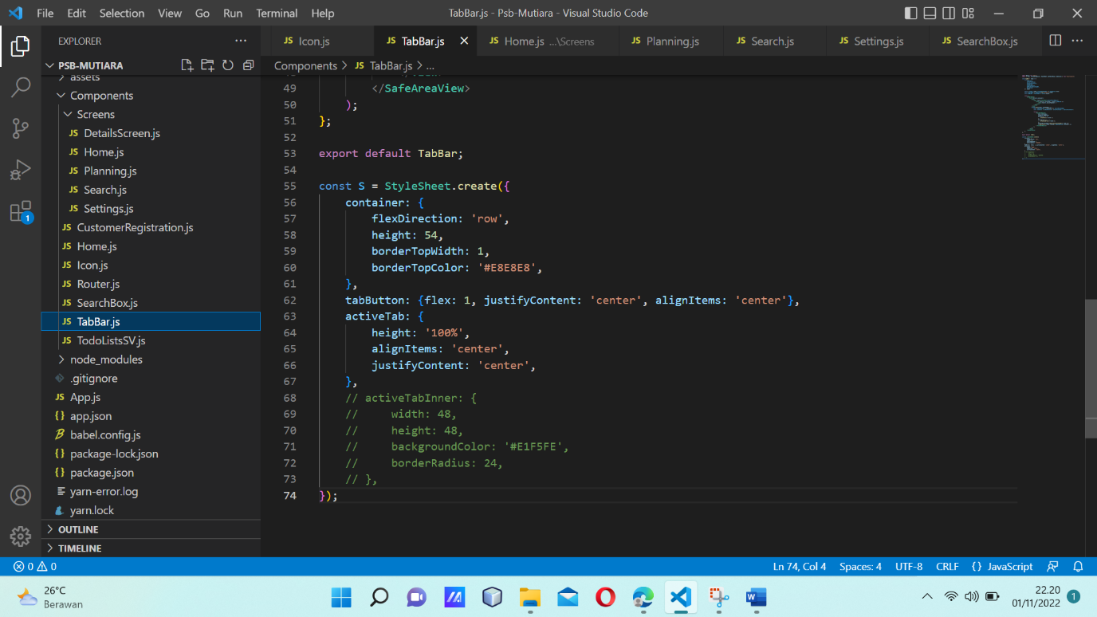

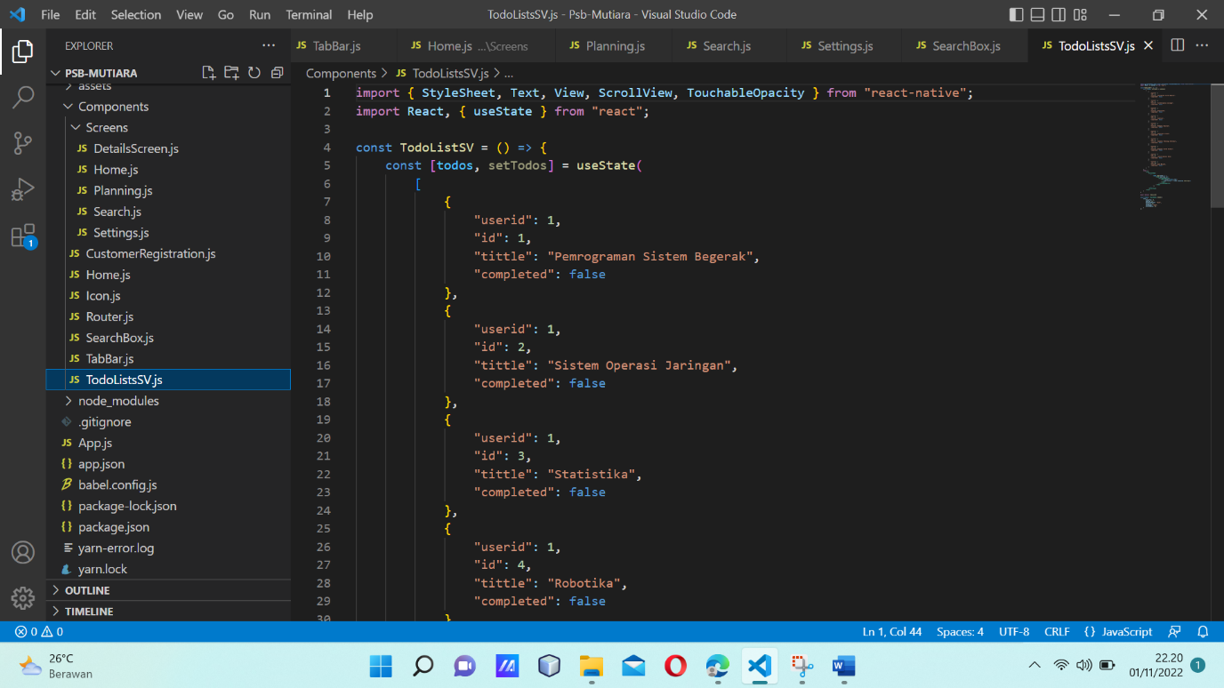

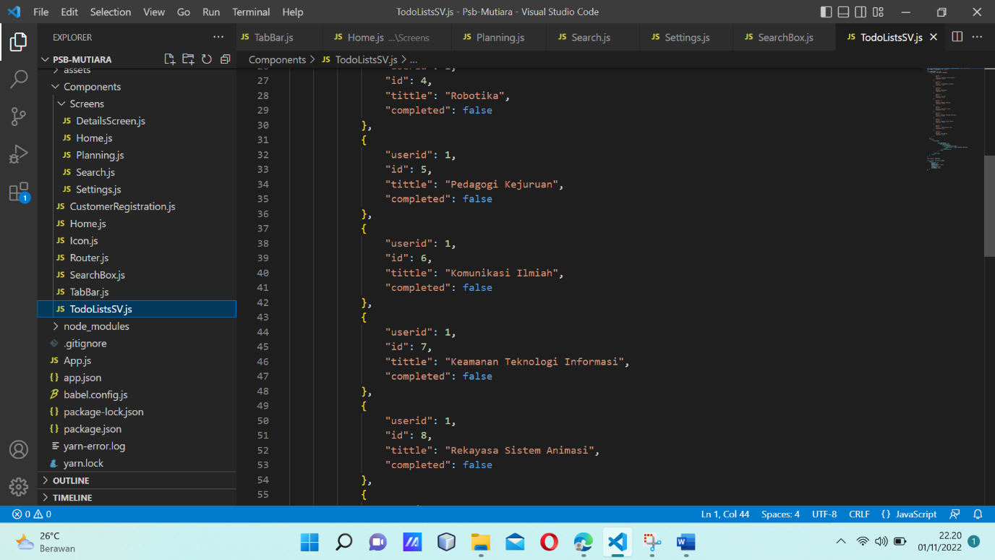

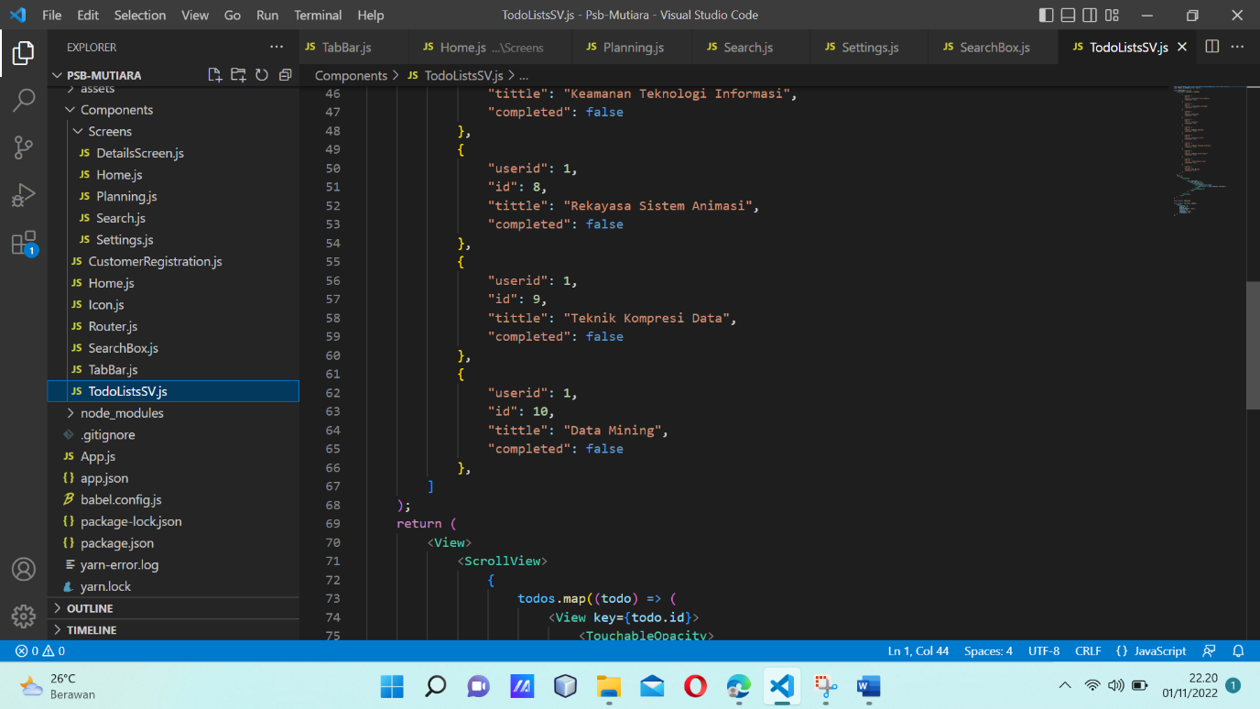

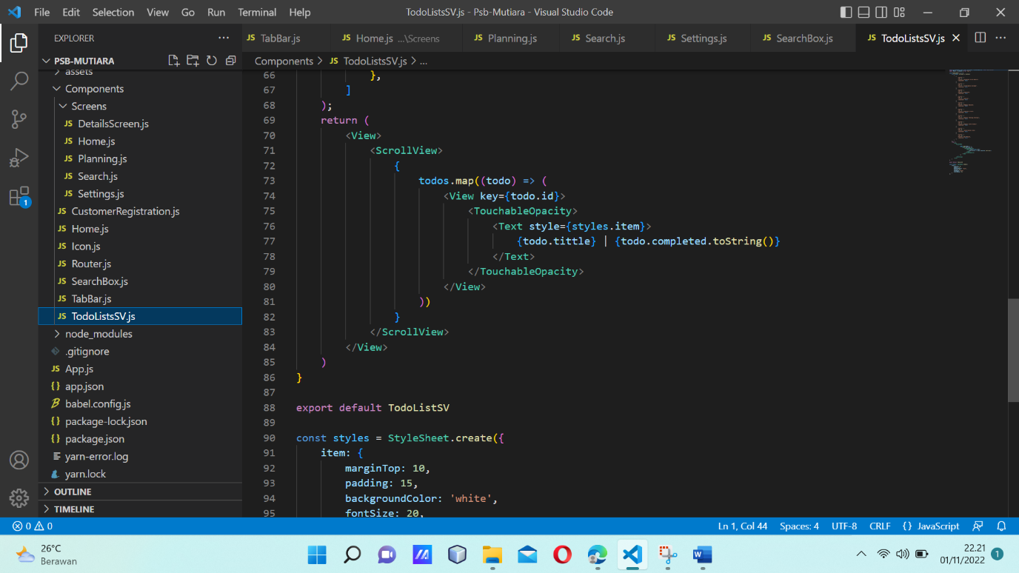

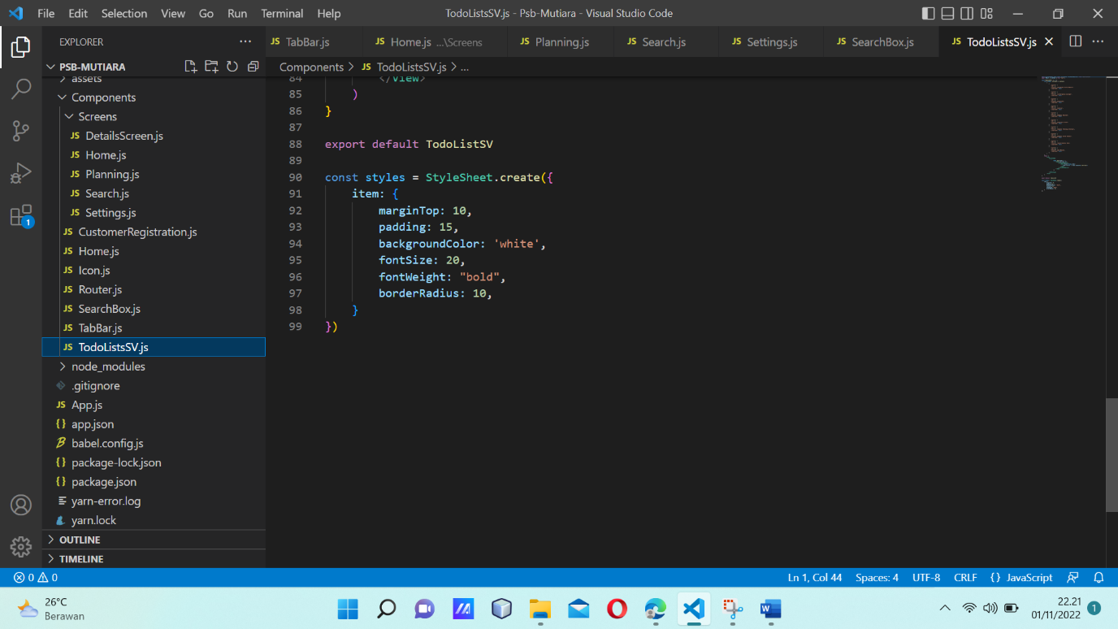

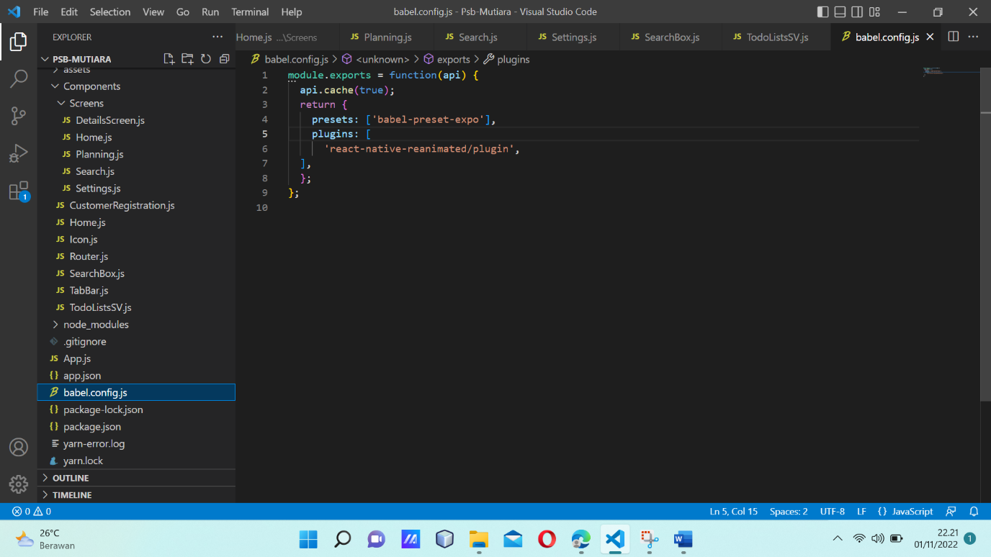

OUTPUT

